March 18, 2019

To: Jim Estes, Steve Leitman, Felicia Coleman, Mike Allen, Leslie Sturmer and Ed Camp

Re: Apalachicola work

Hi,

I’ve spoken with a couple of you the last few weeks about different ideas for work in Apalachicola related to efforts planed by FSU as well as FWC. I told Jim I would send a few bullet points of thoughts and a few graphs.

(1) The contrast in river discharge that can be seen over the last 12 years is interesting (see graphs below). I think with this contrast a retrospective analyses of FWC floodplain fish sampling (if that has continued), oyster fisheries independent and fisheries dependent data, NFWF, FIM and DEP fish monitoring, data could be informative in terms of how the ecosystem has responded to this level of variation in discharge.

(2) Could this variation in discharge could be patitioned in terms of what is driving the variation – precipitation? Dam operations? Withdrawals within the basin? Other?

(3) The FL v GA lawsuit continues and how this lawsuit relates to research efforts should be thought about. It does not appear that the lawsuit considers information since 2012. This may be worth thinking about. See recent filings in February and March. https://www.ca10.uscourts.gov/special-master-142

(4) Can the modeling efforts, field collections, reviews, or any other materials from the ongoing lawsuit be made available for review on a website somewhere?

(5) I think our two papers from Ecology and Society (Pine et al. and Camp et al.) are still very relevant worth looking at again.

(6) I think it is worth evaluating whether F is really high even if landings are low because of very low population size. I thought the reference to Melanie Parker’s survey efforts that is made in Ray Grizzle’s recent paper is concerning in terms of the number of monitoring sites where oystes were absent.

(6) Ed Camp (now an Assistant Professor at UF, earlier a post-doc working on Apalach) has a lot of great ideas and a variety of modeling tools that could be very useful for the planned Apalachicola efforts. He has submitted a series of really nice proposals to NOAA RESTORE and other funding sources. A couple of people have confused me and Ed as people have made comments about “since I was going up for tenure”. I’ve been tenured about 9 years.

I’m unsure if I would commit to working in Apalachicola again. I think there are a lot of opportunities for learning given river discharge conditions the last 10 years and think this is a good place to start. I encourage the whole process to be as above board, transparent, and reproducible as possible.

Thanks,

Bill Pine



Figure 1. Apalachicola River mean daily discharge (1000’s of CFS) from USGS station 02358000 (Chattahoochee) from January 1, 1950-March 2019.

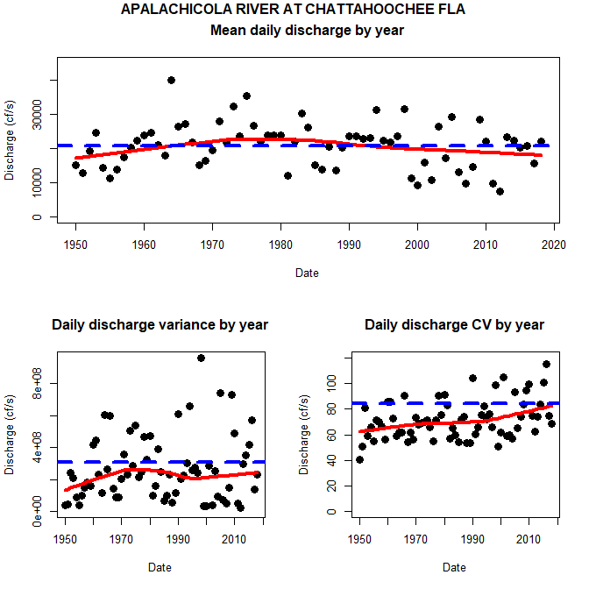

Figure 2. Apalachicola River mean daily discharge (1000’s of CFS) from USGS station 02358000 (Chattahoochee) from 1950-2018. The thick blue line in each graph is the value (mean, variance or discharge depending on graph) for the period of data used. The red line is a lowess smoothing line just for visualization. The dots colors are the quantiles (0 to 100) so the 50% quantile is the median. The thick black line is the discharge for a given year. As an example 2007 much of the year was in the first quantile 0-25% where as 2014 was in the 75-100% quantile. It is interesting that there is contrast in these data with years including 2006-2008, 2011 and first part of 2012 as generally below median (or below 25% quantile) and the years since mid 2012-2018/2019 (so far) above median.



Figure 3. Various river discharge plots for Apalachicola River discharge (1000’s of CFS) from USGS station 02358000 (Chattahoochee) from 1950-2018.



Figure 4. Apalachicola River mean daily discharge (1000’s of CFS) from USGS station 02358000 (Chattahoochee) from 2005-2019. The colors are the quantiles (0 to 100) so the 50% quantile is the median. The thick black line is the discharge for a given year. As an example 2007 much of the year was in the first quantile 0-25% where as 2014 was in the 75-100% quantile. It is interesting that there is contrast in these data with years including 2006-2008, 2011 and first part of 2012 as generally below median (or below 25% quantile) and the years since mid 2012 is generally a period of higher discharge.



Figure 5. Duration curves for river discharge (y axis, CFS) using Apalachicola River mean daily discharge (1000’s of CFS) from USGS station 02358000 (Chattahoochee). The black line in both plots is for a time period from 1950-2018. The red line on the plot on the left is for a time period from 2005-2013 and on the right from 2014-2018. Again, contrast in these data with the 2005-2013 period generally much lower than the 1950-2018 data set where as in more recent years 2014-2018 similar to the longer term record.



Figure 6. Summary of salinity from the NERRS site at Cat Point using the SWMPr R package for years 2005-2018. Salinity is measured near the bottom. These are just standard output graphs from this R package. I think the anomaly plots on the right side are interesting.

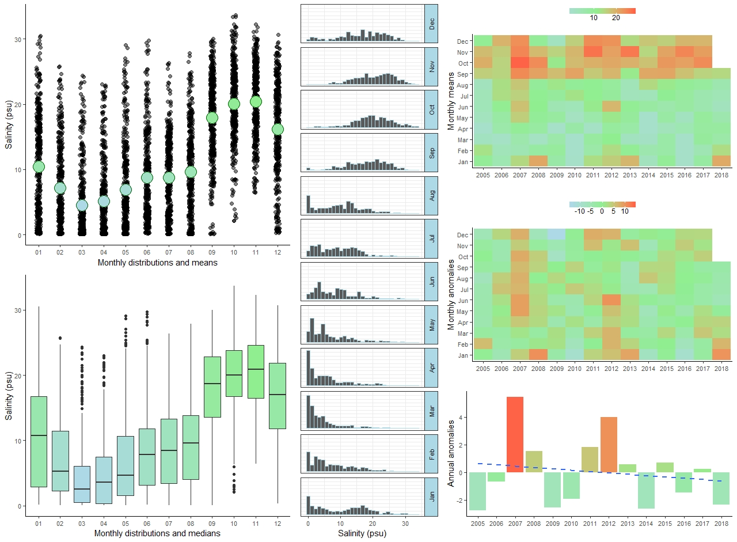

Figure 7. Summary of salinity from the NERRS site at East Bay using the SWMPr R package for years 2005-2018. Salinity is measured near the bottom. These are just standard output graphs from this R package. I think the anomaly plots on the right side are interesting. There are some data missing for 2018 for East Bay I think because the data failed initial QA/QC and I’m only using the data that passed initial QA/QC. These data are likely available in the “revised” dataset that can be downloaded.



Figure 8. Landings (lbs), Effort (trips), and CPUE as Catch/trip for oysters from Apalachicola area for 1986-2018 using FWC landings data available here https://public.myfwc.com/FWRI/PFDM/ReportCreator.aspx.